Chapter 3, Solution 71

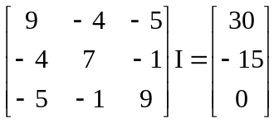

We can now use MATLAB solve for our currents.

>> R=[9,–4,–5;–4,7,–1;–5,–1,9]

R =

9 –4 –5
–4 7 –1
–5 –1 9

>> V=[30,–15,0]'

V =

30
–15
0

>> I=inv(R)*V

I =

6.255 A
1.9599 A
3.694 A

